Elementary Leave Your Leaves Lesson 1
Elementary Lessons designed and created by Katie Henson
Comparing Leaves of Broad-Leaved Trees
Introduction: Unless you were to look more closely, it’s natural to assume that all trees are pretty much the same when it comes to how their leaves change in the fall. Broad-leaved (deciduous) trees are ones whose leaves change colors and fall to the ground. One thing that students may not realize is that there’s a rich diversity of trees around them, and that leaves look and behave very different as a result of this diversity. The purpose of this activity is to give students the chance to look at diverse leaves more closely and learn what exactly makes trees in their backyard so different from each other.
Procedure: Have students go outside and collect 3-5 leaves that have different shapes. Have them draw or trace the leaves in a leaf journal. Next to each drawing they will put the following information: primary color of each leaf, number of leaf lobes*, length (inches), width (inches). For younger students, have each student choose their favorite leaf. They will share with the class why they like this leaf and what they wrote about it in their journal.
Optional for older students: Have students turn in their journals and pool the class data. If students are learning descriptive statistics, you can show them the class data and ask them to calculate the range of lobe number, the mode leaf color, the median length, etc. You can also go into Excel and create a graph based on the pooled data. For example, plotting lobe number on the y axis and leaf length on the x axis will reveal if long leaves are more likely to be highly lobed.
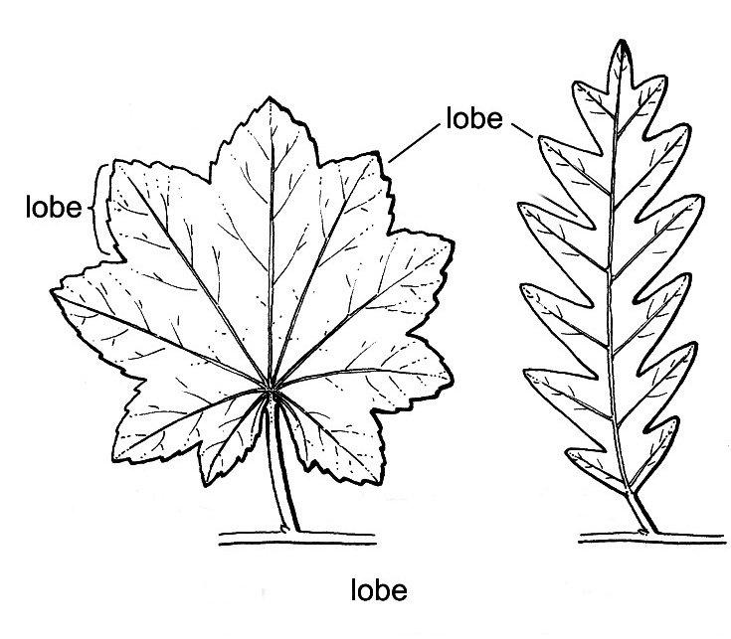
*reference for what a lobe looks like on a maple and oak leaf. Note that lobes do not include the tiny, serrated tips that may be at the end of each leaf, but rather the sections that make up the overall shape of the leaf. Here, the maple leaf has 9 lobes and the oak has 13. Credit: UC Davis Plant Sciences lab manual
Questions for the class:
- In what aspects were leaves similar or different?
- Why aren’t all leaves the same color at the same time? For example, why are some leaves yellow while others are still green?
- Some trees have long, thin leaves and others have short, wide leaves. How might different leaf shapes help different kinds of trees?
- Is it possible for one tree to have different leaf shapes? When you see leaves with different shapes on the ground, do you think they came from the same tree, or different trees?

